**10. GEOMETRY**

**Solutions Exercise – Easy**

1. (b)

*∠COF* = 55°

∴*∠EOD* = 55° (vertically opposite angle)

also *∠BOE* = 115°

*∠BOD* = *∠BOE* − *∠EOD*

*∠BOD* = 115° − 55°

*∠BOD* = 60°

*∠COF* + *∠FOB* + *∠BOD* = 180° (linear pair)

*∠*55° + *∠FOB* + 60° = 180°

*∠FOB* = 180° − 115°

*∠FOB* = 65°

*∠FOD* = 65° + 60° = 125°

∴ *∠AOE* = *∠FOB* = 65° (vertically oppsoite angle)

**Alternate Method:**

*∠BOE* + *∠AOE* = 180° (Linear pair)

115° + *∠AOE* = 180°

*∠AOE* = 180 − 115 = 65°

2. (a)

Let the angles be 2*x*, 3*x*, 5*x*.

⇒ 2*x* + 3*x* + 5*x* = 180°

*x* = 18°

Largest angle = 5*x* = 5 × 18 = 90°

3. (a)

*∠PRS* = *∠ABS* = 70°

∴ *∠SRQ* = 180° − 70° = 110°

*∠RQS* + *∠QSR* + *∠SRQ* = 180°

∴ *∠SQR* = 180° − (110° + 20°) = 50°

4. (d)

Let that angle be *x*.

Supplement of this angle = 180 − *x*

∴

⇒ 3*x* = 180 − *x*

⇒ *x* = 45°

5. (a)

In a right angled triangle,

(*x* + 1)2 = *x*2 + (*x* − 1)2

⇒ *x*2 + 2*x* + 1 = *x*2 + *x*2 − 2*x* + 1

⇒ *x*2 − 4*x* = 0

⇒ *x* (*x* − 4) = 0

⇒ *x* = 4 [ *x* cannot be equal to 0]

∴ Hypotenuse = (4 + 1) = 5

6. (b)

*∠ACB* = *∠BAC* (angles opposite to equal sides)

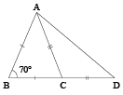

Similarly,

*∠ADC* = *∠CAD* = (angles opposite to equal sides)

∴ *∠ACB* = *∠BCA* = 

*∠ACD* = 180° − 55 = 125°

∴ *∠ADC* = *∠CAD*

= 

7. (d)

To construct a triangle sum of any two sides has to be greater than the third side. Hence, option (d) is the correct answer.

8. (a)

We know that (*a + b + c*)2 = *a*2 + *b*2 + *c*2 + 2*ab* + 2*bc* + 2*ac* = 3*ab* + 3*bc* + 3*ac*

Now assume values of *a*, *b*, *c* and substitute in this equation to check the options.

Alternate Method:

The equation *a*2 + *b*2 + *c*2 = *ab + bc + ca* can also be written as:

(*a – b*)2 + (*b – c*)2 + (*c – a*)2 = 0.

Hence, *a = b = c*.

9. (c)

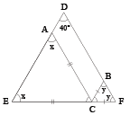

Here *∠ACE*=180 – 2*x* , *∠BCF* = 180 – 2*y*

and *x + y* + 40° = 180° (In ∆*DEF*)

So *x + y* = 140°

So, *∠ACB* = 180° – *∠ACE* – *∠BCF*

= 180° – (180° – 2*x*) – (180° – 2*y*)

= 2(*x + y*) – 180°

= 2 × 140 – 180 = 100°

10. (b)

Using the Basic Proportionality Theorem,

= 

Multiplying the two we get,

= 3 : 1.

Thus, *CD : PQ = BD : BQ* = 4 : 3 = 1 : 0.75

11. (c)

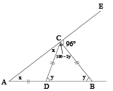

Using exterior angle theorem

*∠A* +*∠B* = 96°

*i.e*. *x + y* = 96 ..... (1)

Also *x* + (180 – 2*y*) + 96 = 180°

∴ *x* – 2*y* + 96 = 0

∴ *x* – 2*y* = – 96 ..... (2)

Solving (1) and (2),

*y* = 64° and *x* = 32°

∴ ∠*DBC* = *y* = 64

12. (c)

Let *n* be the number of sides of the polygon.

∴ Interior angle = 8 × Exterior angles

⇒ 

⇒ *n* − 2 = 16

⇒ *n* = 18

13. (c)

Sum of all the interior angles of the polygon is 360°.

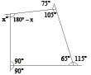

∴ (180° − *x*) + 105° + 65° + 90° = 360°

⇒ *x* = 80°

14. (d)

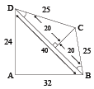

*CE* = 

(Since *DBC* is isosceles triangle.)

Assume *ABCD* is a quadrilateral

where *AB* = 32 m, *AD* = 24 m, *DC* = 25 m, *CB* = 25 m

and ∆*DAB* is right angle.

Then *DB* = 40 m because Δ*ADB* is a right-angled triangle and DBC is an isosceles triangle.

So, area of Δ*ABD* = 

Area of Δ*BCD* = 

Hence area of *ABCD* = 384 + 300 = 684 sq. m

15. (d)

In ∆*ABC*, if *a*2 > *b*2 + *c*2, then ∠*A* > 90° ⇒ *A* = 120°

16. (a)

Four common tangents can be drawn to two non-intersecting circles.

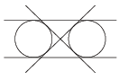

17. (d)

We know, *PC × PD = PA × PB*

∴ (4 + 3) *×* 4 = 8 *×* *PB*

⇒ *PB* = 

∴ *AB = AP − BP*

= 8 − 3.5 = 4.5 cm

18. (c)

In ∆*PQO*,

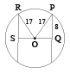

(17)2 = (8)2 + (*OQ*)2

∴ (*OQ*)2 = 289 − 64 = 225

*OQ* = 15

∴ OS = 23 − 15 = 8

Now in ∆*ORS*,

(*RS*)2 = (17)2 − (8)2 = 289 − 64 = 225

∴ *RS* = 15 cm

Hence, length of other chord = 15 × 2 = 30 cm

19. (b)



*OP* = 28 cm

*OQ* = 21 cm

*PQ* = *OP* – *OQ* = 7 cm



20. (b)

*PR + QS = PQ* = 7 cm

Now 

⇒ *QS* = 3 cm

21. (c)





cm

22. (a)

*∠ACB* = 60° (Angle in equilateral triangle)

*∠ACD* = 180 − 60 = 120°

*∠CAD* = *∠CDA* = 

⇒ ∠*ADC* = 30°

23. (c)

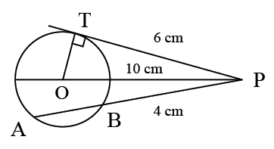

Since PT is tangent

*PA* . *PB* = *PT*2 or *PT*2 = 4(4 + 5)

∴ *PT* = 6 cm

∴ Radius = 

**Solutions Exercise – Medium**

1. (b)



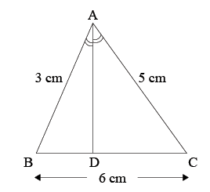

∴ 

∴ *BD* *: DC* = 3 : 5

Now, BD = 



= 2.25 cm

2. (d)

Let the three points be *A*, *B*(1, 3) and *C*(82, 30).

Then, *AB* = 









= 

Now, *AB + BC* = 



Since, *AB + BC = AC* it means ABC is a straight line.

3. (d)

If *KL* = 1, then *IG* = 1 and *FI* = 2

Hence, tan θ = 

Thus, θ none of 30°, 45° and 60°.

4. (c)

Area of quadrilateral *ABCD* = 

Area of quadrilateral *DEFG* = 

Hence, ratio = 12 : 7

5. (a)

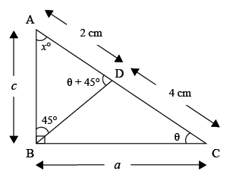

In ∆*ABC*

*x* + θ + 90° = 180°

⇒ *x* + θ = 90°

In ∆*ABC*, from Sine formula, 

In ∆*ABC*, *x* + 45° + ∠*ADB* = 180°

⇒ ∠*ADB* = θ + 45°.

From sine formula,

⇒

⇒

Also, sin (θ + 45°) = sin θ cos 45° + cos θ sin 45°

⇒ 

⇒ 

(Using sin2 θ + cos2 θ = 1)

⇒ 

Alternate Method:

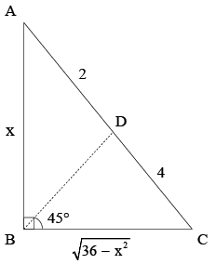

*BD* is the bisector of ∠*ABC*

∴ 

⇒ 5*x*2 = 36

⇒

6. (d)

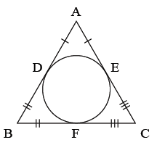

*BD = x*

*AD = AE* = 5 − *x*

*EC* = *CF* = 6 − (5 − *x*) = 1 + *x*

*BD* = *BF* = 7 − (1 + *x*)= 6 − *x*

*x* = 6 − *x*

*x* = 3

7. (b)

Let the side of the square be *a* m, then



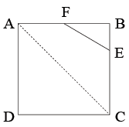

Area of ∆*FEB* = 

Given, 

⇒ *a*2 = 108 × 12 = 1296

Now, In ∆*ADC*,

*AC*2 = *AD*2 + *DC*2

= *a*2 + *a*2 = 2*a*2

= 2 × 1296 = 2592

∴ 

8. (a)

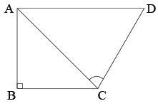

Given, *AD*2 = *AB*2 + *BC*2 + *CD*2

In ∆*ABC*,

*AC*2 = *AB*2 + *BC*2

∴ *AD*2 = *AC*2 + *CD*2

∴ ∠*C* = 90°

9. (a)

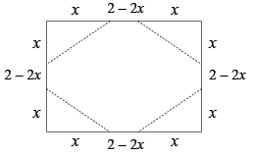

Let the length of the edge cut at each corner be *x* m. Since the resulting figure is a regular octagon,

∴ 

⇒ 

10. (a)

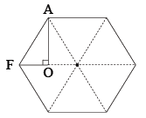

It is very clear, that a regular hexagon can be divided into six equilateral triangles. And triangle *AOF* is half of an equilateral triangle.

Hence the required ratio = 1 : 12

11. (b)

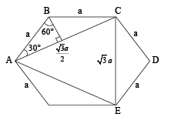

Δ*ACE* is equilateral triangle with side.

Area of hexagon =

Area as Δ*ACE* = 

Therefore, ratio = 

12. (b)

Given that *BC* and *EF* are each 2 cm. Triangle *ABF* has two equal side (*AB = AF*), so the perpendicular from A to the line *BF* will divided *ABF* into two congruent right triangles, *AHF* and *AHB*, each with hypotenuse 2.

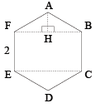

The angle *FAB* is 120°, since the total of all the angles of the hexagon is 720°.

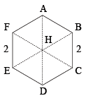

So, each of the two triangles is a 30° − 60° − 90° triangle with hypotenuse 2.

So, *AH* = 1 and *FH* and *HB* must equal. Therefore, *BF* is 2 and the area of rectangle *BCEF* is 2 × 2= 4 cm2.

13. (d)

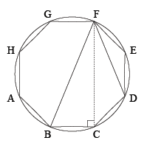

*∠BCF* = 90° (Angle in a semicircle)

*∠BCD* = 135° (Octagon)

⇒ *∠FCD* = 45°

Since *BCDF* is a cyclic quadrilateral,

*∠DFB* = 45°

14. (b)

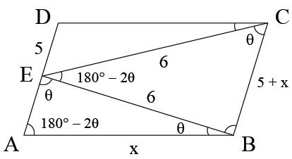

In ∆*CBE*, using sine rule



⇒ 

In ∆*ABE*, cos θ = 

⇒ 

⇒ *x*2 + 5*x* − 36 = 0

⇒ (*x* + 9) (*x* − 4) = 0

⇒ *x* = 4

15. (c)

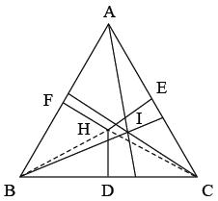

*∠BHC* = 180° − *∠BAC* = 110°, *∠BAC* = 70°,

*∠BIC* = 90° +  *∠BAC* = 125°

16. (b)

Since the sides of the triangle are 6 cm, 8 cm and 10 cm (*i.e*. *AB*2 + *BC*2 = *AC*2), this is on right-angled triangle.

∴ The area of the triangle

=  × 6 × 8 = 24 sq. cm

∴ Area of the triangle = Area of the rectangle

8 × Length = 24

Length = 

So, perimeter = 22 cm

17. (a)

In ∆*RBD* and ∆*SCD*,

*∠D* is common to both triangles and *∠B* =*∠C* (because each angle is right angle.)

∴ 

Similarly, ∆*TDB* and ∆*SCB* are similar.

∴ 

∴ 

∴ 

18. (c)

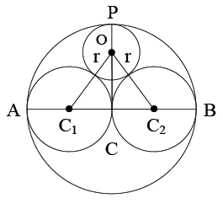

In ∆*OC*1*C*2,

(*OC*1)2 = (*OC*)2 + (*CC*1)2

⇒ (*r* + 1)2 = (*PC − OP*)2 + 1

⇒ (*r* + 1)2 = (2 − *r*)2 + 1

⇒ *r*2 + 1 + 2*r* = 4 + *r*2 − 4*r* + 1

⇒ 6*r* = 4

⇒ *r* = 

19. (c)

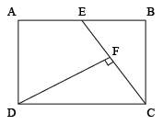

Area of ∆*CED* =  × *CE* × *DF*

= × 30 × 20 = 300 sq. cm

Area of ∆*CED* =  [Area of rectangle *ABCD*]

Hence, area of rectangle *ABCD* = 600 cm2

20. (b)

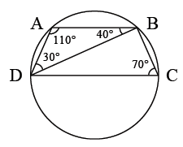

Since ∠C*DB* = 70°.

∠*C* + ∠*B* = 180° − 70° = 110° (Cyclic quadrilateral)

In ∆*CAB*, ∠*ABC* = 180° − (30° + 110°) = 40°

21. (a)

In (I) remember, a square is also a rectangle and in (b) remember, a square is also a rhombus.

22. (a)

Perimeter of the semicircle = *r* (π + 2)

Perimeter of ∆*RPQ* = 

∴ 

23. (c)

We have *AB* + *AC* = 5 *BC* and *AC* − *BC* = 8 or *AC* = *BC* + 8.

So, *AC* = *BC* + 8 and *AB* = 4(*BC* − 2).

By Pythagoras' theorem, *AB*2 + *BC*2 = *AC*2

Expressing *AB* and *AC* in terms of *BC*, we get *BC* = 5.

∴ *AB* = 12 and *AC* = 13

So, area of the rectangle = 5 × 12 = 60.

24. (d)

Since the trapezium is inscribed inside a circle, it must be isosceles, *AD = BC* = 20 cm. Since another circle is inscribed inside the trapezium, *AB + CD = AD + BC* = 20 + 20 = 40 cm

But *AB* = 16 cm ⇒ *CD* = 40 − 16 = 24 cm

25. (c)

Each exterior angle = 180 − 150 = 30°

Number of sides = 

26. (c)

Exterior angle = 30°

Hence, Number of sides = 

27. (b)

*ABPQ* is a cyclic Quadrilateral.

Hence, ∠*APB* = 180° − 130° = 50°

⇒ ∠*AOB* = 100°

Now ∠*OAB* = ∠*OBA* = 

28. (d)

Sum of the angles marked

= 5 × 360° − (Sum os interior angles)

= 1800° − 540° = 1260°

29. (d)

∠*PAB* = ∠*PRB* = 35° (angles in the same segement)

30. (a)

∠*ABQ* = 180° − 35° − 25° = 120°

∠*ABR* = 180° − 120° = 60° = ∠*RPA*

∠*ABP* = 180° − 35° − 90° = 55°

∠*PBR* = 55° + 60° = 115°

31. (c)

∠*BPR* = 180° − 115° − 35° = 30°

32. (d)

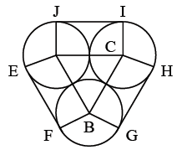

*AB* = 2 cm = *BC = CA*

∴ ∆*ABC* is equilateral

∴ ∠*ABC* = 60°

*EF* will be tangent to circle *A* & *B*.

∴ ∠*AEF* = ∠*BFE* = 90°

∴ *AEFB* & *BCGH* will be rectangles.

*EF + GH + JI* = 2 + 2 + 2 = 6 cm

∴ ∠*FBG* = 360 − 90 − 90 − 60 = 120°

Length of arc *FG* = 

Sum of arc *FG + IH + JE* = 

∴ Total length of rope = 6 + 2π

33. (c)

Area of regular polygon of side '*s*' and number of side '*n*'

= 

= [24 Cot 30°] = 

34. (b)

Use triplets 5, 12, 13

Diagonals of rhombus bisect each other at right angles.

∴ *AO* = 10 cm

∴ *BO* = 

∴ Area of rhombus = × *d*1 × *d*2 = × 20 × 48

= 480 m2

35. (c)

Area = 

= 

= 

36. (c)

Each exterior angle =  and each interior angle

= 

According to the question = 

⇒  ⇒ *n* − 2 = 10

⇒ *n* = 12

37. (a)

By Pythagoras' theorem, the length of th diagonal *BD* is. Now observe that triangles *BCD* and *BCE* are similar.

Thus,, and since *BC* = 1, if follows that *BE* = . The area of rectangle *BDFE* is therefore × = 2

38. (b)

Interior angle + exterior angle = 180°

3*x* + *x* = 180°

*x* = 45°

Exterior angle = 45°

Number of side = 

**Solution Exercise – Difficult**

1. (b)

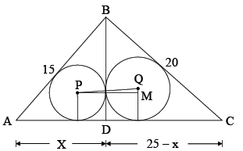

Now, In Δ*ACB*

*AB*2 = *AC*2 + *BC*2

= (15)2 + (20)2

= 625

⇒ *AB* = 25

(15)2 – *x*2 = (20)2 – (25 – *x*)2

⇒ *x* = 9

⇒ *BD* = 12

Area of Δ*ABD* = 





Area of Δ*BCD* = 





In Δ*PQM*,

*PM* = *r*1 + *r*2 = 7 cm

*QM* = *r*2 – *r*1 = 1 cm

Hence, *PQ* = 

2. (b)

If the radius of the field is *r*, then the total area of the field =.

The radius of the semi-circles with centre *P* and *R* =.

Hence, their total area = 

Let the radius of the circle with centre *S* be *x*.

Thus, *OS* = (*r* – *x*), OR =  and *RS* =.

Applying Pythagoras theorem, we get



Solving this, we get *x* =.

Thus, the area of the circle with centre *S* =.

The total area that can be grazed =.

Thus, the fraction of the field that can be grazed

= 

∴ The fraction that cannot be grazed =  = 28% (approx.)

3. (c)

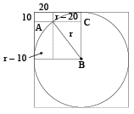

Let the radius be r. Thus by Pythagoras’ theorem for ∆ABC we have (*r* – 10)2 + (*r* – 20)2 = *r*2

*i.e*. *r*2 – 60*r* + 500 = 0. Thus *r* = 10 or 50.

The radius of the circle should be 50 cm (as *r* = 10 cm is not possible).

4. (d)

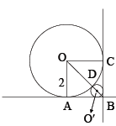

Let the radius of smaller circle = *r*

∴ *O′B* = 

∴ *OB = O′B + O′D + OD*



Also *OB* = 

⇒ 

⇒

5. (d)

Case I: Chords on same side of the centre.

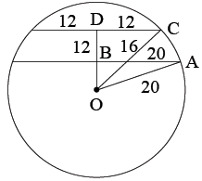

*OB*2 = *OA*2 – *AB*2 = 202 – 162 = 144

*OB* = 12

*OD*2 = 202 – 122 = 400 – 144 = 256

*OD* = 16

*BD* = 4 cm

Case II: Chords on opposite side of the centre.

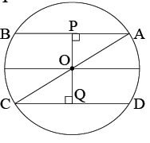

*AB* = 32 cm

*CD* = 24 cm

*OP* = 

*OP* = 12 cm and

*OQ* = 

*OQ* = 16 cm

Distance = *PQ* = 12 + 16 = 28 cm.

6. (b)

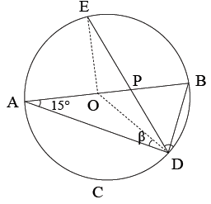

Let *O* be the centre of circle. Radius of circle = 10 cm

∴ Circumference = 2 × π × 10 = 20 π cm

Length of arc (*BD*) = 

∴ ∠*BOD* = 

and ∠*DAB* = 15°, ∠*ADB* = 90°

⇒ ∠*ADE* = ∠*BDE* = 45°

So, ∠*EOD* = 120° ⇒ ∠*EOB* = 90°.

In ∆*EOD*, *OD* ⇒∠*OED* = ∠*ODE*

∴ 2∠*OED* + 120° = 180°

⇒∠*OED* = 30°.

Now, 

7. (d)

The parallelogram is a square with each side equal to radii of the bigger circle, *i.e*., 8 cm, and ∠*A* = ∠*B* = ∠*C* = ∠*D* = 90°.

The diameter '*D*' of incircle of a square equals its side. Hence, *D* = *AB* = *BC* = *CD* = *DA* = 8. Area of the incircle is 

8. (d)

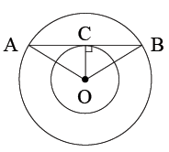

Given *AB* is a tangent at point *C* ⇒ *OC* ⊥ *AB*

Also *AB* = 8, so *AC = BC* = 4.

Now area of ∆*OAB* = 

⇒ *OC* =  = 3 cm. In right ∆*ACO*, *OA*2 = *OC*2 + *AC*2 = 32 + 42 = 25.

So, *OA* = radius of the outer circle = 5 cm.

9. (d)

*AD* = *AF* = 6 cm; *BD* = *BE* = 5 cm; *EC* = *FC* = *x*.

Applying Pythagoras theorem,

*AC*2 = *BC*2 + *AC*2 *i.e*. 121 + (5 + *x*)2 = (6 + *x*)2.

Solving, we get *x* =55.

*AC* = 55 + 6 = 61 cm

10. (d)

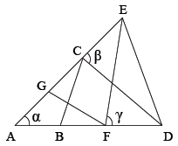

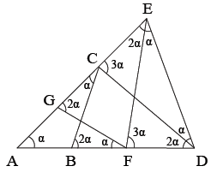

Let ∠*EAD* = α. Then ∠*AFG* = α and also ∠*ACB* = α.

Therefore, ∠*CBD* = 2α (exterior angle to Δ*ABC*).

Also ∠*CDB* = 2α (since *CB = CD*).

Further, ∠*FGC* = 2α (exterior angle to Δ*AFG*).

Since *GF = EF*, *FEG* = 2α. Now *DCE* = *DEC* = β

(say). Then ∠*DEF* = β – 2α.

Note that ∠*DCB* = 180 – (α + β).

Therefore, in Δ*DCB*, 180 – (α + β) + 2α + 2α = 180 or

β = 3α. Further ∠*EFD* = ∠*EDF* = γ (say).

Then ∠*EDC* = γ – 2α. If *CD* and *EF* meet at *P*, then

∠*FPD* = 180 – 5α (because β = 3α).

Now in Δ*PFD*, 180 – 5α + γ + 2α = 180 or γ = 3α.

Therefore, in Δ*EFD*, α + 2γ = 180 or α + 6α = 180 or

α = 26 or approximately 25.

11. (c)

Direct 90° + A = 90 +  (144) = 162°

12. (c)

In a trapezium, there are 2 pairs of supplementry adjacent angles. (c) does not fulfill the condition.

13. (a)

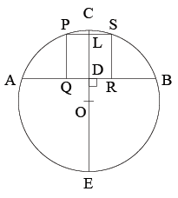

As given, *PQRS* is the square inscribed in the segment *ACB* of which the chord is *AB* and height is *CD*. Then *AB* = 8 cm and *CD* = 2 cm. Let the side of the square measure *x* cm.

Then *FG* = *LD* = *x* cm.

*ED* × *CD* = *AD* × *AB*

∴ 

But *EL = ED + DL* = (8 + *x*) cm

*CL* = *CD* − *LD* = (2 − *x*) cm and *FL* =  *FK* = 

Since *FL*2 = *CL* × *LE*,

∴ 

Solving the above equation, we get *x* = 1.9 cm.

14. (a)

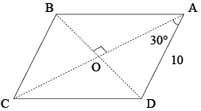

∆*AOD*, 

*OD* = *AD* sin 30 = 5 cm

And



*OD* and *OA* are the radii of 2 circles

Difference in the areas = 

**Solutions for 15 − 17:**

*A*1*A*2 = 2*r*, *B*1*B*2 = 2*r* + *r*, *C*1*C*2 = 2*r* + 2*r*

Hence,

*a* = 3 × 2*r*

*b* = 3 × (2*r* + *r*)

*c =* 3 × (2*r* + 2*r*)

15. (a)

Difference between (1) and (2) is 3*r* and that between (2) and (3) is 3*r*. Hence, (a) is the correct choice.

16. (c)

Time taken by *A* = 

Therefore, *B* and *C* will also travel for time.

Now speed of *B* = (10 + 20)

Therefore, the distance covered

= 

= (2*r* + ) × 3 = *B*1*B*2 + *B*2*B*3 + *B*3*B*1

∴ *B* will be at *B*1.

Now time taken by for each distance are





*i.e*. 

*i.e*. 

We can observe that time taken for *C*1*C*2 and *C*2*C*3 combined is, which is same as time taken by *A*.

Therefore, *C* will be at *C*3.

17. (b)

In similar triangles, ratio of Area = Ratio of squares of corresponding sides.

Hence, *A* and *C* reach *A*3 and *C*3 respectively.

18. (b)

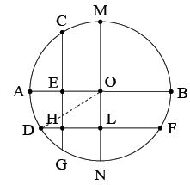

*AE* = 1 cm, *BE* = 2 cm & *NL* = 1 cm, *ML* = 2 cm

*HL = OE* = 

*DL = DH + HL*

*DL = DH* + 

*OB = AO* = radius = 1.5

*DO*2 = *OL*2 + *DL*2



⇒ 

19. (d)

*OR* = 11 cm,

*OQ* = 7 cm,

*PR* = *PQ* = *r*

⇒ 2*r* = 11 + 7

⇒ *r* = 9 cm

20. (d)

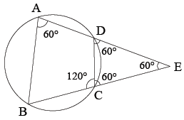

Given, ∠*BAD* = 60°

So, ∠*BCD* = 120° (Cyclic quadrilateral)

⇒ ∠*DCE* = 60° = ∠*CDE* (Since *CE = DE*)

Thus, ∆*CDE* is equilateral.

But we cannot compare the lengths of *BE* and *AD*.

21. (a)

If radius = 6.5 cm, then *BD* = 13 cm.

By Pythagoras theorem,

The other side of the rectangle has to be 12.

(Since 5, 12 and 13 from a Pythagoras triplet)

So, area (∆*PCD*) = 

It does not matter which side is 12 or 5. Area remains the same.

22. (d)

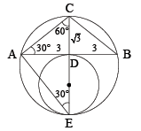

Since ∠*ADC* = 90° and ∠*DAC* = 30°

∴ ∠*ACD* = 60°

Since *CE* is the diameter, ∠*CAE* = 90°

Thus, ∠*AEC* = 30°

*AD* = 3 (Given)



*CD* = 

*CE* = 2 × *AC* = 4

∴ Diameter *DE* = *CE* − *CD* = 3

Radius of smaller circle = 

23. (b)

Each exterior angle lies between 44° and 38°. Now 40 is the only number between 44 and 38 which is divisible by 360°, hence number of sides = 

24. (c)

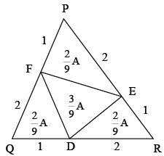

Take an equilateral triangle and try out from the given options.

25. (b)

Let the coin with center *O* be placed on the table. Another coin with center P is placed is placed on the table such taht it just touches the previous coin. Let radius of coin = 1 cm.

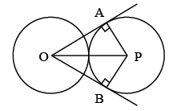

Join *OA*, *OB*, *PB* and *AP*.

*∠OAP* = 90° = *∠OBP*

*AP = PB* = 1 cm,

*OP* = 2 cm.

*AO = OB* = 

∴ ∆OAP and ∆OPB is a right triangle with angles 90°, 60° and 30°.

*∠AOP* = 30° = *∠BOP*

*∠AOB* = 30° + 30° = 60°

There will be six coins around coin touching each other

.

27. (d)

A cyclic quadrilateral area = 

where *s* = semiperimeter and *a*, *b*, *c*, *d* are sides of quadrilateral.

∴ *s* = 

Area = 

= 

= 5 × 4 × 15 × 2 = 600 units.

28. (d)

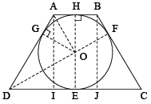

*DE = DG* ( ∆*DOE*  ∆*DOG*)

*AG = AH* ( ∆*AGO*  ∆*AHO*)

*DI* = *JC* ( figure is isosceles trapezium)

*DI* =  = 40 *DG = DE* = ;

*AG = AH* = 

∴ *AD* = 85

∴ *AI* = 75 cm = diameter.

29. (a)

*∠BAC* = 180 − 140 = 40°

*∠ACB* = 180 − 70 = 110°

So, *∠CAD* = 40°

∴ *BC < AC < CD*  (as side opposite to bigger angle is greater.)

30. (b)

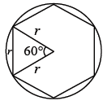

It wouild be equilateral triangle

Number of sides = 

**MENSURATION**

**Solution Exercise – Easy**

1. (d)

Let the length of shorter piece be *x*. Then, second and third length will be *x* + 3 and 2*x*.

∴ *x* + (*x* + 3) + 2*x* = 123

⇒ 4*x* = 120 ⇒ *x* = 30 cm

Also, 2*x* ≥ (*x* + 3) + 5

⇒ *x* ≥ 8

Also, *x* + (*x* + 3) + 2*x* ≤ 123

⇒ 4*x* ≤ 120

⇒ *x* ≤ 30

2. (d)

Let dimensions of a stone be 3*x*, 2*x*, *x*.

∴ Volume of stone = 10368

⇒ 3*x* 2*x* *x* = 10368

⇒ 6*x*2 = 10368

⇒ *x*3 = 1728

⇒ *x* = 12

∴ Dimensions are 36 dm, 24 dm, 12 dm.

∴ Entire surface area of a stone

= 2(*lb + bh + hl*)

= 2(36 × 24 + 24 × 12 + 12 × 36)

= 2(864 + 288 + 432)

= 3168 dm2

∴ Total polished cost

= 3168 × 0.02

= Rs. 63.36

3. (b)

Let the side of cube = *x*

Volume of cube = *x*3

Let the radius of sphere = *r*

Now, sphere can fit inside the cube, so



= 

= 

4. (c)

Let length and breadth of blackboard be *x* m and (*x* − 8) m.

Then, *x* × (*x* − 8) = (*x* + 7) (*x* − 12)

⇒ *x*2 − 8*x* = *x*2 − 5*x* − 84

⇒ 

*x* − 8 = 20 m

5. (a)

Area of isosceles triangle

= 

Height of triangle = 

Equal sides of triangle = 

6. (b)

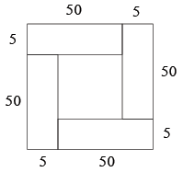

Area of inner square = 55 × 55 − 4 × 50 × 5

= 3025 − 1000 = 2025 cm2

7. (c)

Let *R* be the radius of each circle. Then  which implies that, *i.e*. *R*2 = 4, *i.e*. *R* = 2.

Then the length of the square is 8. Thus, the area of the square is 64, while the area covered by each coin is π22 = 4π. Since there are four coins, the area covered by coins is 4(4π ) = 16π. Thus, the area not covered by the coins is 64 – 16π = 16(4 – π).

8. (d)

The surface area of a sphere is proportional to the square of the radius.

Thus,  ( Surface Area of *B* is 300% higher than *A*)

∴ 

The volume of a sphere is proportional to the cube of the radius.

Thus, 

Or, *VA* is th less than *B* *i.e*. 

9. (c)

It’s standard property among circle, square and triangle, for a given perimeter, area of circle is the highest and area of the triangle is least whereas area of the square is in-between, *i.e*. *c > s > t*.

10. (c)

Required difference = *l × b × h* − π*r*2*h*

= 

= 2100 − 1650 = 450 cm3

11. (a)

Circumference of the circle = 2π*r*



Therefore, *r* =  = 7 or *BD* = 2*r* = 14

**Solution Exercise – Medium**

1. (d)

Let the sides of two squares be *x* m and *y* m.

Then, 29*x*2 + 1 = 6*y*2 ..... (1)

and 9*x* − 1 = 4*y* ..... (2)

From equations (1) and (2),



⇒ 29*x*2 + 1 = × (81*x*2 + 1 − 18*x*)

⇒ 232*x*2 + 8 = 243*x*2 + 3 − 54*x*

⇒ 11*x*2 − 54*x* − 5 = 0

⇒ 11*x*2 − 55*x* + *x* − 5 = 0

⇒ (11*x* + 1)(*x* − 5) = 0

∴ *x* = 5 m as *x* ≠ −

*y* = 11 m

∴ *y* − *x* = 6 m

2. (c)

Volume of bigger cube = 10 × 10 × 10 = 1000 cm3

Volume of smaller cube = 

∴ Edge of smaller cube = 

and edge of bigger cube = 10 cm

∴ Required ratio = 

3. (a)

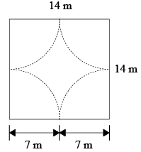

Total area of the square field = 14 × 14 = 196 m2

Area grazed by four horses in 11 days

= 

= 

Ungrazed area = 196 − 154 = 42 m2

This area is sufficient for 

4. (d)

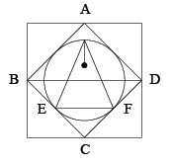

*BD* | | *EF* and *BD* = 2*EF*

∴  [ *BD = a*]

∴ Area of equilateral triangle = 

= 

5. (c)

Area = 40 × 20 = 800

If 3 rounds are done, area = 34 × 14 = 476

⇒ Area > 3 rounds

If 4 rounds ⇒ Area left = 32 × 12 = 347

Hence, area should be slightly less than 4 rounds.

6. (b)

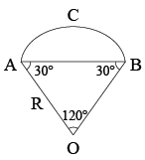

Let *R* be the radius of the circle. In ∆*AOB*, ∠*AOB* = 120°, and *OA = OB*

∠*OAB* = ∠*OBA* = 30­°

In ∆*ABO* by sine formula:



Length of arc *ACB + AB* = *P* ⇒ 

∴  ..... (1)

Area of ∆*AOB* = × *AB* × *R* × sin 30° = × *R*× *R ×*  = 

Required area = 

=  ..... from (1)

= 

7. (d)

The given conditions about the centre of the bigger circle implies that this centre is always in contact with the periphery of the smaller circle. The above condition can be satisfied only if the diameter of the smaller circle is equal to the radius of the larger one, *i.e*. 7 m. Thus, the centre of the smaller circle is at a distance of 3.5 m from the centre of the larger circle. The distance covered in one revolution will be



8. (c)

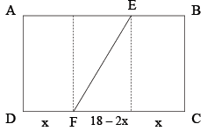

When the sheet is folded we would find that *FC* coincides with *AF*.

So, (18 − *x*)2 = 122 + *x*2

Solving we get *x* = 5 cm

So, *EF* = *L* = 

9. (a)

2π*r* = 308

*r* = 154 × = 49 m

Since volume = 

= × π × 492 12 = 30184

Volume of half filled vessel = × 30184 = 15092 m3

∴ Time taken =  = 2515.33 s ≈ 42 minutes.

10. (a)

Area of sector = 

= 

11. (a)

For isosceles right triangle area = 

12. (b)

The side of each smaller square formed by joining the mid-pionts of the previous squre will be  times the previous side. Therefore, the area of the next squre will be  of the previous one. Hence, sum of the area of the squares

= 

= a GP with *a* = 1 and *r* = 

Therefore, sum of the areas = 2 m2

13. (d)

∆*QSR* is a right-angled isoceles triangle.

*RS* = 4 units

So, *QS* =  units, *OS* = 

Hence, shaded area = 

⇒ (2π − 4) sq. unit

14. (a)

Volume of cone: Volume of cylinder : Volume of semisphere

= 

= 1 : 3 : 1

**Alternate Method:**

If the diameters and the heights of a cone and a cylinder are same, then the volume of the cone is always of the volume of the cylinder. So, the ratio of the volume of cone to the volume of cylinder is 1 : 3. There is only one option, *i.e*. (a).

15. (b)



16. (d)

Total area of playground = 750 × 2π*rh*

= 

= 2475 × (10)4 cm2 = 2475 m2

∴ Total cost of levelling = 2475 × 2 = Rs. 4950

17. (c)

Let the diameter of third ball be 2*r*.



⇒ 

⇒ 

⇒ 

⇒ 

∴ 

18. (b)

Volume of ice-cream = 6 × 5 × 2 = 60 cm2

Also, *L* × *b* × 2 = 48

⇒ *L* × *b* = 24

Now, *L* = 6 − 6 × 10% = 5.4

*b* = 5 − 5 × 10% = 4.5

∴ *L* × *b* = 5.4 × 4.5 = 24.3

Clearly, 5 < *L* < 5.5

19. (a)

The whole height h will be divided into n equal parts.

Therefore, spacing between two consecutive turns =.

20. (b)

The four faces through which string is passing can be shown as

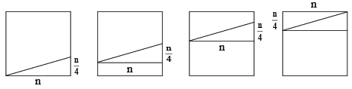

Therefore, length of string in each face

= 

= 

Therefore, length of string through four faces

= 

21. (c)

As  = number of turns = 1 (as given). Hence, *h* = *n*.

**22**. (b)

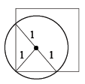

Remaining area = 

Remaining proportion = 

23. (d)

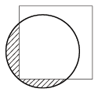

Area = 

= 

24. (a)

Let length of square section of bar be *l*.

∴ 1 = *l* × *l* × 36

⇒

∴ Volume of exact cube = 

Since, cost of 1 m3 = 108

∴ 

25. (a)

Curved surface area of a frustum = π(*r + R*)*L*

Here, 

and 



∴ Curved surface area = 

= 119.26 ≈ 118.4 m2

26. (a)

Total surface area of prism

= lateral surface area + 2 × (area of base)

Here, 

∴ Required area

= 

= 

= 1620 + 2 × 126 = 1872 sq. m

27. (a)

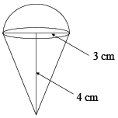

Surface area of hemisphere = 2π*r*2

= 2π(3)2 = 18π cm2

Now 

Surface area of cone = π*rl*

= π × 3 × 5 = 15π = 33π cm2

28. (d)

Volume of the parallelepiped = 5 × 4 × 3 = 60 cm3

Volume of the cube = 4 × 4 × 4 = 64 cm3

Volume of the cylinder = π × 3 × 3 × 3 = 27π

= 84.8 cm3

Volume of the sphere = π(3)3

= 36π = 113.04 cm3

The required decreasing order is D, C, B and A.

29. (d)

The four circles could be centred at the four vertices of a square, but that is not necessary. The data in the question is consistent with the condition that the quadrilateral formed by the 4 centres is rhombus rather than a square. The shaded area would be the area of the rhombus minus the area of the 4 sectors (which add up to the area of the one of the circles). As the area of the rhombus cannot be determined the area of shaded portion cannot be determined.

**Solution Exercise – Difficult**

1. (c)

Volume of the figure formed = 

Cross section of the figure formed

BC = Hypotenuse = 13 cm

AC − DC = 5 cm

AB = BD = 12 cm

Since  BC × AM =  AB × AC [Equating the area of the triangles]

∴ *AM* = *r* = 

= 

Volume = 

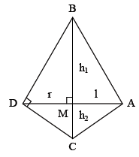

2. (b)

Let *PQ* = *x*.

Then, *PR* = 

Also, area of shaded portion

= Area [Square (*PQRS*)] − Area [∆*QYZ*] − Area [∆*XRY*] − Area [Trapezium *PZXS*]

⇒ Area =





⇒ Area = 

⇒ Area = 

Area [Square (*ABCD*)] = 

Ratio = 

3. (c)

Let the depth of the drainlet be *d* m.

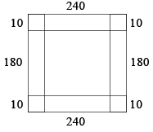

Then,

2 × 240 × 10 × *d* + 2 × 180 × 10 × *d* + 4 × 100 × *d*

= 240 × 180 ×

⇒ 8800*d* = 600 × 18

⇒ 

4. (c)

Following rule should be used in this case: The perimeter of any polygon circumscribed about a circle is always greater than the circumference of the circle and the perimeter of any polygon inscribed in a circle is always less than the circumference of the circle.

Since, the circles is of radius 1, its circumference will be 2 π . Hence, *L*1(13) > 2 π and *L*2(17) < π .

So, {*L*1(13) + 2 π } > 4, and hence  will be greater than 2.

5. (c)

The entire surface area we are looking for consists of the areas of the outside cylinder and the inside cylinder, plus the areas of the larger top and bottom circles, minus the areas of the smaller top and bottom circles.

The lateral surface area of the outside cylinder is 2π*rh* = 2π (2)(6) = 24π.

Lateral surface area of inside cylinder = 2π × 1 × 6 = 12π.

The lateral surface areas of the larger top and bottom circles are each π*r*2 = π (22) = 4π.

And the surface area, then, is 24π + 12π + 2(4π) − 2(π) = 42π square metres.

6. (d)

Volume of sphere = 

Let the number of cylinders be *k*. Then, 2*k* is the number of cones.

*R*cylinder = *R*cone = *H*cone = *H*cylinder and *H*cylinder = 4

⇒ 

⇒ 

So, number of cones = 42.

**Solutions (Q. Nos. 7 − 9):**

Suppose *A* = θ

7. (c)

Length of wire = arc + 2*r*

= 

8. (a)

Area of sector = 

9. (c)





Area of sector = 

**Solutions (Q. Nos. 10 − 11):**

Length of cylindrical portion = (8 − 1) cm = 7 cm

10. (c)

External surface area = 2π (1) (7) +  [4π (1)2] cm2 = 14π + 2π cm2 = 16π cm2

11. (a)

Capacity of the tube = π (1)2 (7) +  [π (1)3] c.c.

= 7π + π c.c. = π c.c.

12. (b)

Volume of the frustum = π (6)2 (8) −π (3)2 (4)

= π (36 × 8 − 9 × 4) = 84 π c.c

Volume of cylinder = π(3)2 (5) = 45 π c.c.

⇒ Total volume = 84π + 45π = 129π c.c.

13. (c)

Lateral area of frustum = π(6) × − π × 3

 = 60π − 15π = 45π cm2

Curved surface area of cylinder = 2π (3) (5) = 30π cm2

Area of the top face = π(6)2 = 36π cm2

Area of bottom face = π(3)2 = 9π cm2

⇒ Total surface area = 45π + 30π + 36π + 9π = 120 π cm2

**Solutions (Q. Nos. 14 − 15):**

Let *h* cm the height from the top face of the cylinder to the apex of the cone.

 ⇒ *h* = 6 cm

⇒ Height of cylinder = 24 − 6 cm = 18 cm

14. (a)

Volume of the remaining portion = π (8)2 (24) − π (2)2 (18) = π (512 − 72) = 1382.3 = 1380 c.c.

15. (b)

Weight of the figure = 7.85 gm/cc × 1380 cc = 10833 gm.

16. (b)

Let *M* be the mid-point of the line *AC* onthe horizontal plate. *VM* will then be the height of the container.

*AC* = 

*AM* =  *AC* = 

In Triangle *AVM*, *VM*

= 

17. (c)

Capacity of the container = × base area × height

= × (2)2 × = 1.89 m3

18. (c)

The base area formed by the water = 1 × 1 = 1

The volume of water = 

The fraction of the water = 

19. (a)

Volume of hemisphere = π*r*3

Volume of cylinder = π*r*2*h*

⇒ π*r*3 = π*r*2*h*

 = *h*



⇒ *r* : *h* = 3 : 2

20.

I. (d)

Area of the section =  π*r*2 + = 136, *r*2  = 136

⇒ *r* = 6.8 cm

II. (b)

Curved surface area of hemisphere = 2π*r*2

Total surface are of cylinder = 2π*rh* + π*r*2

Total external surface area = 2π*r*2 + 2π*rh* + π*r*2

= 3π*r*2 + 2π*rh* = 3π*r*2 + 2π*r* = 3π*r*2 + 

= π*r*2  = π(6.8)2 (4.33) = 629 cm2

**Solutions (Q. Nos. 21 − 23):**

Volume of metal = length × breadth × height

⇒ 36 × 28 × 24 = 24192 cc

21. (b)

As 1000 cc weight 350 kg.

∴ 24192 cc weights 

22. (c)

Length of pipe made out of 24192 cc of metal having outer radius 8 cm and inner radius 6 cm is given as π*r*12 *L* − π*r*22 *L*

⇒ 24192 ⇒ π *L* [82 − 62] = 24192

*L* = 274.9 cm ⇒ 275 cm.

23. (a)

We know that 1 m3 = 1000 litre, 1000 cm3 = 1 litre. Then, water is floweing at the rate of 2800 gallon/hour *i.e*.

= 

Hence, π × *r*2 × m/s = 3.53

Solving, × (0.66)2 × *Y* = 3.53

⇒ *Y* = 312.5 m/s

24. (a)

Volume =  Base area × height

512 = × *x*2 × 6

⇒ *x*2 = 256

⇒ *x* = 16

*l*2 = *h*2 +  = 62 + 82 = 100

⇒ *l* = 10

Side of square is 16 cm and slant edge is 10 cm.

25. (b)

Diagonal of Square = 

Diameter of Circle = 

Required Area = 

= 

**CO-ORDINATE GEOMETRY**

1. (c)

Since the cost curve is linear we consider cost curve as *y = Ax + B* where *y* is total cost. Now, for *x* = 80, *y* = 220000.

∴ 220000 = 125*A + B* ..... (1)

and for *x* = 125, *y* = 287500.

∴ 287500 = 125*A + B* ..... (2)

Subtracting (1) from (2),

45*A* = 67500 or *A* = 1500

From (1) 220000 − 1500, 80 = *B* or *B* = 220000 − 120000 = 100000

Thus equation of cost line is *y* = 1500*x* + 100000.

For *x* = 95, *y* = 142500 + 100000 = Rs. 242500.

∴ Cost of 95 A.C. will be Rs. 242500.

2. (d)

Equation of line passing through (− 1, 3) and (1, 6).

(*y* − 3) =  (*x* − (− 1))

*y* − 3 =  (*x* + 1)

Since lines are parallel.

So, slope will be equal.

*y* − 3 =  (*x* − 6)

2*y* − 6 = 3*x* − 18

3*x* − 2*y* − 12 = 0.

3. (d)

Let cost of 5 pieces is 80 be (5, 80) and 8 pieces is (8, 116).

Let us form a linear equation

*y* − 80 =

*y* − 80 = 

*y* − 80 = 12[*x* − 5]

*y* − 80 = 12*x* − 60

12*x* − *y* + 20 = 0

So, cost of 10 pieces is

12 × (10) − y + 20 = 0

*y* = Rs. 140

4. (c)

Let number of coffee = *x*

and cost = *y*

In (*x*, *y*) form (50, 320) and (80, 380)

Let form a linear equation for this

*y* − 320 = 

*y* − 320 = 

*y* − 320 = 2 × (*x* − 5)

*y* − 320 = 2*x* − 100

2*x* − *y* + 220 = 0

for 110 coffees

2 × 110 − *y* + 220 = 0

*y* = Rs. 440

5. (a)

Let find the point of intersection of 3*x* − 2*y* = 6 and 3*x* + 2*y* = 18

3*x* − 2*y* = 6

3*x* + 2*y* = 18

6*x* = 24

*x* = 4

*y* = 3

So, (4, 3) lies in 1st quadrant.

6. (a)

Let us find the distance between (2, 3), (1, 4) and (1, 4), (− 3, 8) and (2, 3), (− 3, 8).

*AB* = 

=  ..... (1)

*BC* = 

=  ..... (2)

*AC* = 

= 

We can clearly see that

*AB + BC = AC*

It mean points lies on same line, it cannot be possible in other cases.

7. (d)

*ax* + (*b + c*)*y* − *p* = 0

Slope of line =  ..... (1)

But *a + b + c* = 0

*a* = − (*b* + *c*)

Putting in equation (1)

Slope = 

8. (a)

Let the ratio in which the line *x = y* divides the line joining the point (1, 4) and (2, − 2) be 1 : λ.

∴ 

λ + 2 = 4 λ − 2

∴ 4 = 3 λ

λ = 

1 : λ = 

9. (c)

The centroid of the triangle formed by the vertices (2, 3), (6, 6) and (−2, −3) is 

∴ Therefore, the perpendicular distance from (2, 2) to the line *y* = 

= 

10. (b)

If (−2, 7), (−4, 8) and (1, 4) are the three consecutive vertex, then fourth vertex is [− 2 + 1 − (− 4), 7 + 4 − 8] *i.e*. (3, 3)

If (− 2, 7), (1, 4) and (− 4, 8) are the three consecutive vertices, then fourth vertex is (− 2 − 4 − 1, 7 + 8 − 4) *i.e*. (− 7, 11)

If (1, 4), (− 2, 7) and (− 4, 8) are the three consecutive vertices, then the fourth vertex is [1 − 4 − (− 2), 4 + 8 − 7] *i.e*.

(− 1, 5).

11. (c)

Let find the root of the equation *x*2 − 7*x* + 12 = 0

*x*2 − 4*x* − 3*x* + 12 = 0

*x*(*x* − 4) − 3(*x* − 4) = 0

*x* = 4, 3

According to question,

=

3*x* + 4*y* = 12

12. (b)

*AB* = 

Hence, area = 8 sq. units

13. (d)

Assume that the radii of each of the spheres and the can are 1, then the volume of each ball is  and the total volume of 3 balls is. Since the height of the can is 6 (the diameter of each sphere is 2), the volume of the can is π(1)2 (6) = 6π

So, the balls take up  of the can.

14. (c)

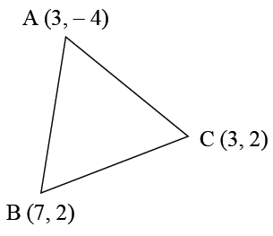

Slope of BC = 0

∴ Equation of line perpendicular to *BC* and passing through *A* is *x* = 3

Slope of *AB* = 

∴ Equation of the perpendicular line

(*y* − 2) =  (*x* − 7) ⇒ 3*y* − 6 = − 2*x* + 14

⇒ 2*x* + 3*y* = 20

Solving we get, *x* = 3, *y* = 

∴ Orthocentre is .

15. (a)

The formula for number of points inside a triangle is

*n* − 1*C*2 = 41 − 1*C*2 = 40*C*2 = 

16. (d)

Slope of line joining (5, 1) and (*x*, 7)

= 

Again Slope of line joining (*x*, 7), (3, − 1) is

= 

∴ 

Checking the options, we find that none of the values satisfies. Hence, option (d).

17. (d)

∆ = 

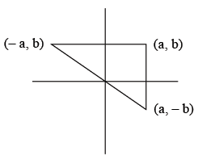

Hence, option (d).

**TRIGNOMETRY**

1. (d)

The length of the diagonals = 

Side of the square = 

Area =  = 14.5 sq. units

2. (b)

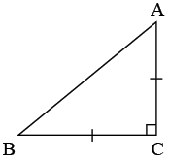

*AB*2 = 272 ; *BC*2 = 136 ; *CA*2 = 136

⇒ *BC*2 + *CA*2 = *AB*2 and *BC = CA*

⇒ The triangle is right -angled isosceles triangle.

**Solutions (Q. Nos. 3 − 4):**

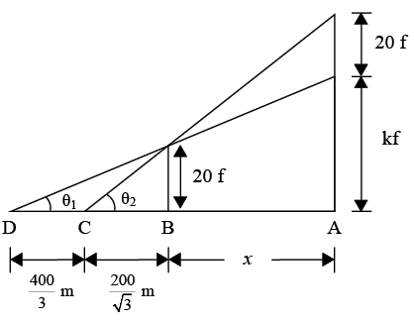

Let '*f*' be the height of each floor

Let *k* + 20 be the number of floors of building *A*.

*CB* = *DB* − 

tan θ1 = 

⇒  ..... (1)

tan θ2 =  ..... (2)

From (1), *x* + 200 = 10*k* ..... (3)

From (2), *x* = 10*k* ..... (4)

*x* = 200 = 3*x* ⇒ *x* = 100m

*k* = 30.

But we cannot find the value of *f*.

3. (a)

4. (d)

5. (c)

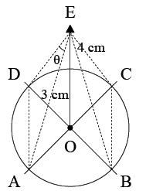

Let *ABCD* be a circular ring and *E* be a point above the ring.

From point *E*, 4 equal strings are attached at equals intervals to the points *A*, *B*, *C* and *D*.

Now, in ∆*ODE*,

*DE*2 = 42 + 32 = 25

⇒ *DE* = 5 cm = *AE*

Also,∠*AOD* = 90°

In ∆*AOD*,

*AD*2 = 32 + 32

⇒ *AD* = 

Applying cosine rule in ∆*ADE*,



= 

⇒ 

6. (b)

(sin *A +* cos *A*)2 + (sin *A* −cos *A*)2

= sin2 *A* + cos2 *A* + 2 sin *A* cos *A* + sin2 *A* + cos2 *A* − 2 sin *A* cos *A*

= 1 + 2 sin *A* cos *A* + 1 − 2 sin *A* cos *A* = 2

7. (d)

Let *OB* be the pole.

If *A* was the initial position of the pole, then AB = 75 m

Now, in ∆*AOB*, tan 60° = 

In ∆*COB*,

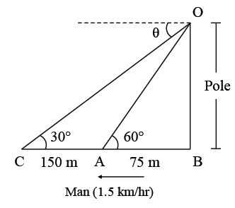

tan 30° = 

or *CA* = 225 − 75 = 150 m

Speed = 1.5 km/hr = 25 m/min.

∴ Time elapsed = 

8. (b)

If Sin *A* and Cos *A* are the roots

So, sum of roots

Sin *A* + Cos *A* =  ..... (1)

Product of roots =  ..... (2)

Squaring equation (1),

(Sin *A* + Cos *A*)2 = 

Sin2 *A* + Cos2 *A* + 2 Sin *A* Cos *A* = 







2*ac* = *b*2 − *a*2

or *a*2 − *b*2 = − 2*ac*

9. (a)

Let *CD* be the light house and Boat is moving from *A* to *B*.

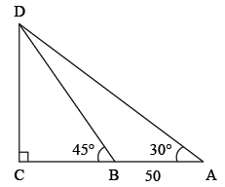

tan 30° = 

 ..... (1)

tan 45° = 

*DC = BC* ..... (2)

Substituing (2) in (1),



50 + *DC* = 

*DC* = 

*DC* = 

*D* = 68.3 m

10. (a)

Let height of the pole before breaking was *AB*.

It breaks down from point *O* and top part touches the ground at point *T*.

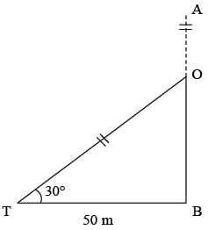

cos 30° = 

*OT* = 

tan 30° = 

*OB* = 

Length of the pole = *OT + OB*

*AB* = 

= 

11. (a)

Sin *Q* + Cos *Q* = 

Squaring both side

(Sin *Q* + Cos *Q*)2 = 

Sin2 *Q* + Cos2 *Q* + 2 Sin *Q* Cos *Q* = 

(1) + 2 Sin *Q* Cos *Q* = 

2 Sin *Q* Cos *Q* = 

Sin *Q* Cos *Q* =  ..... (1)

Now, Sin6 *Q* + Cos6 *Q*

(Sin2 *Q*)3 + (Cos2 *Q*)3

= (Sin2 *Q* + Cos2 *Q*) (Sin4 *Q* + Cos4 *Q* − Sin2 *Q* Cos2 *Q*)

(1)[(Sin2 *Q*)2 + (Cos2 *Q*)2 + 2 Sin2 *Q* Cos2 *Q* − 2 Sin2 *Q* Cos2 *Q* − Sin2 *Q* Cos2 *Q*]

[(Sin2 *Q* + Cos2 *Q*)2 − 3 Sin2 *Q* + Cos2 *Q*]

[(1) − 3 (Sin *Q* + Cos *Q*)2]



= 

= 

= 

12. (d)

Let *x* = 

= 

= 

13. (a)

cot *A* = 

On a triangle it is like

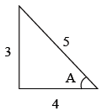

sec *A* = 

tan *A* = 

sec2 *A* − tan2 *A* = 

= 

14. (b)

Let tan (75°) = tan [45 + 30]

Appling the formula,

tan (45 + 30) = 

= 

= 

15. (c)

Sine angle between diagonals is = 30°

Sides of quadrilateral = 8 cm and 12 cm

So, Area of *ABCD*

=  × Product of diagonals × Sine of angle between them

=  × 8 × 12 × = 24 sq. cm

16. (d)

Given 9*A* = π

cos *A* cos 2*A* cos 4*A*

Multiply and divide the given expression with 2 sin*A*,

= 2 sin *A* cos *A* cos 2*A* cos 4*A*

= sin 2*A* cos 2*A* cos 4*A*

= 2 × sin 2*A* cos 2*A* cos 4*A*

= sin 4*A* cos 4*A*



= 

= 

= 

= 